**Assignment 3 Template**

**LAST NAME: Yuan**

**FIRST NAME:Feng**

**USERID: y87feng**

**UWaterloo ID:20600787**

**Problem 1: Fill in the information below based on your data which were generated using your ID number as the seed for the random number generator.**

**n = 30 theta = 0.3430096**

**The first 10 approximate 95% confidence intervals are:**

**[,1] [,2]**

**[1,] 0.1084215 0.4249119**

**[2,] 0.2881420 0.6451913**

**[3,] 0.1646434 0.5020233**

**[4,] 0.3893415 0.7439918**

**[5,] 0.1646434 0.5020233**

**[6,] 0.1360146 0.4639854**

**[7,] 0.1360146 0.4639854**

**[8,] 0.1646434 0.5020233**

**[9,] 0.2881420 0.6451913**

**[10,] 0.1084215 0.4249119**

**Do all 10 intervals contain only values between 0 and 1? Yes**

**Depending on the value of theta is it possible that some intervals will not contain only values between 0 and 1? Why or why not?**

**No, it is impossible. since theta is a probability, it cannot be less than 0 or greater than 1. If some intervals contain the value less than 0 or greater than 1, the sample size must be too small.**

**The proportion of approximate 95% confidence intervals which contain the true value of theta = 0.9462**

**How close is this proportion to 0.95? What are the reasons for this?**

**It is very close to 0.95. For the 95% confidence intervals, we are 95% confident that the interval will contain the true value of theta, and 5% confident that the interval won’t contain the true value of theta.**

**The first ten 15% likelihood intervals (approximate 95% likelihood intervals) are:**

**[,1] [,2]**

**[1,] 0.1325515 0.4386053**

**[2,] 0.2974039 0.6413444**

**[3,] 0.1840830 0.5096281**

**[4,] 0.3904118 0.7321158**

**[5,] 0.1840830 0.5096281**

**[6,] 0.1578485 0.4745779**

**[7,] 0.1578485 0.4745779**

**[8,] 0.1840830 0.5096281**

**[9,] 0.2974039 0.6413444**

**[10,] 0.1325515 0.4386053**

**Do all 10 likelihood intervals contain only values between 0 and 1? YES**

**Depending on the value of theta is it possible that some likelihood intervals will not contain only values between 0 and 1? Why or why not?**

**No, it is impossible. since theta is a probability, it cannot be less than 0 or greater than 1. If some intervals contain the value less than 0 or greater than 1, the sample size must be too small.**

**The proportion of 15% likelihood intervals which contain the true value of theta = 0.9462**

**How close is this proportion to 0.95? What are the reasons for this?**

**The proportion of 15% likelihood intervals is approximately equal to 95% confidence interval. 0.9462 is very close to 0.95. For the 95% confidence intervals, we are 95% confident that the interval will contain the true value of theta, and 5% confident that the interval won’t contain the true value of theta.**

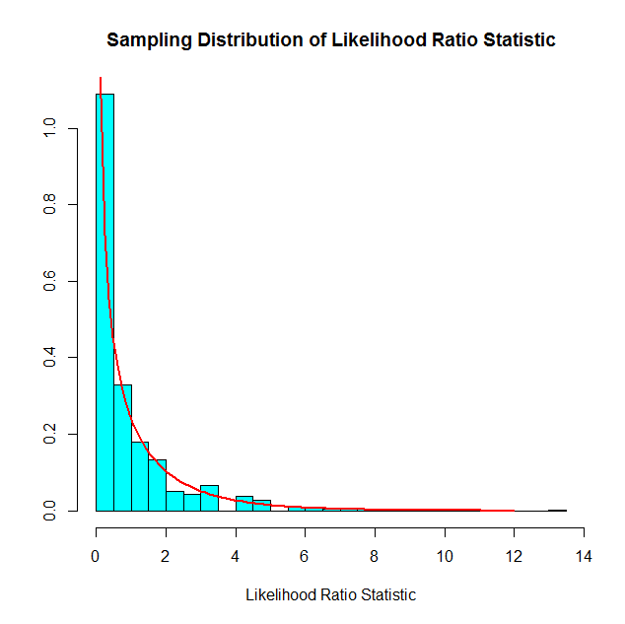

**For Binomial data the likelihood ratio statistic is a discrete or continuous random variable?**

**For Binomial data the likelihood ratio statistic is a discrete random variable .**

**How well does the Chi-squared(1) probability density function agree with the sampling distribution of the likelihood ratio statistic as approximated by the relative frequency histogram?**

**The Chi-squared(1) doesn’t fit the relative frequency histogram very well, since Chi-squared(1) is a normal distribution, and the sample size is not very big, then the sample distribution doesn’t approximate normal distribution very well. Some columns are higher than the red line, some columns are lower than the red line.**

**n = 100 theta = 0.3430096**

**The first 10 approximate 95% confidence intervals are:**

**[,1] [,2]**

**[1,] 0.3136007 0.5063993**

**[2,] 0.2565140 0.4434860**

**[3,] 0.2565140 0.4434860**

**[4,] 0.2565140 0.4434860**

**[5,] 0.3136007 0.5063993**

**[6,] 0.2010626 0.3789374**

**[7,] 0.3039800 0.4960200**

**[8,] 0.2471531 0.4328469**

**[9,] 0.2565140 0.4434860**

**[10,] 0.2285707 0.4114293**

**The proportion of approximate 95% confidence intervals which contain the true value of theta = 0.9516**

**How close is this proportion to 0.95? What are the reasons for this?**

**0.9516 is very close to 0.95. For the 95% confidence intervals, we are 95% confident that the interval will contain the true value of theta, and 5% confident that the interval won’t contain the true value of theta.**

**The first ten 15% likelihood intervals (approximate 95% likelihood intervals) are:**

**[,1] [,2]**

**[1,] 0.3173358 0.5071683**

**[2,] 0.2616948 0.4458226**

**[3,] 0.2616948 0.4458226**

**[4,] 0.2616948 0.4458226**

**[5,] 0.3173358 0.5071683**

**[6,] 0.2075858 0.3828682**

**[7,] 0.3079566 0.4970481**

**[8,] 0.2525548 0.4354491**

**[9,] 0.2616948 0.4458226**

**[10,] 0.2344345 0.4145845**

**The proportion of 15% likelihood intervals which contain the true value of theta = 0.9412**

**How close is this proportion to 0.95? What are the reasons for this?**

**The proportion of 15% likelihood intervals is approximately equal to 95% confidence interval. 0.9412 is not very close to 0.95. For the 95% confidence intervals, we are 95% confident that the interval will contain the true value of theta, and 5% confident that the interval won’t contain the true value of theta.**

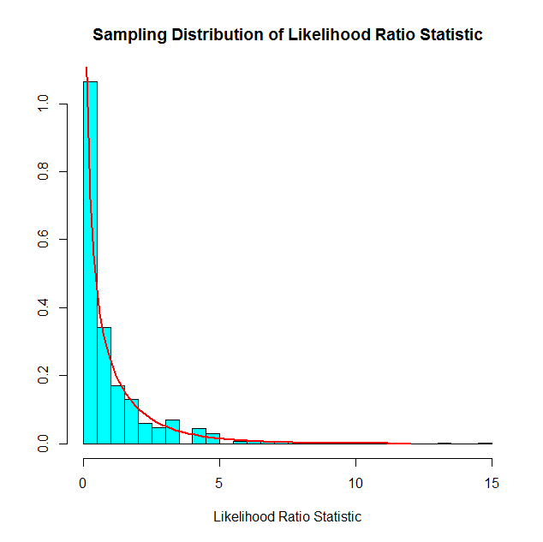

**How well does the Chi-squared(1) probability density function agree with the sampling distribution of the likelihood ratio statistic as approximated by the relative frequency histogram?**

**The Chi-squared(1) doesn’t fit the relative frequency histogram very well, since Chi-squared(1) is a normal distribution, and the sample size is not very big, then the sample distribution doesn’t approximate normal distribution very well. Some columns are higher than the red line, some columns are lower than the red line.**

**Compare the graphs for n=30 and n=100.**

**For their graph of n=30 and n=100, the graph of n= 30 are more approximate to the read line since the columns of the graph of n=30 are closer to the red line than that of the graph of n=100, although the n=100 is a larger sample size.**

**Problem 2: Fill in the information below based on your data which were generated using your ID number as the seed for the random number generator.**

**n = 20 theta =7**

**The first 10 approximate 95% confidence intervals are:**

**[,1] [,2]**

**[1,] 2.684252 6.872827**

**[2,] 4.670064 11.957348**

**[3,] 3.495448 8.949834**

**[4,] 4.169627 10.676017**

**[5,] 6.131971 15.700453**

**[6,] 3.935178 10.075728**

**[7,] 3.955567 10.127934**

**[8,] 3.908622 10.007733**

**[9,] 4.137228 10.593063**

**[10,] 4.471416 11.448726**

**Do all 10 intervals contain only values greater than 0? YES**

**Depending on the value of theta is it possible that some intervals will not contain only values greater than 0? Why or why not?**

**No, it is impossible. since if theta is negative, the probability density function is negative, thus it is impossible. If theta is equal to zero, the divisor will be zero, which is also impossible.**

**The proportion of approximate 95% confidence intervals which contain the true value of theta = 0.925**

**How close is this proportion to 0.95? What are the reasons for this?**

**0.925 is not very close to 0.95. For the 95% confidence intervals, we are 95% confident that the interval will contain the true value of theta, and 5% confident that the interval won’t contain the true value of theta.**

**The first ten 15% likelihood intervals (approximate 95% likelihood intervals) are:**

**[,1] [,2]**

**[1,] 3.183636 7.642630**

**[2,] 5.538892 13.296692**

**[3,] 4.145749 9.952294**

**[4,] 4.945352 11.871836**

**[5,] 7.272837 17.459063**

**[6,] 4.667286 11.204305**

**[7,] 4.691469 11.262359**

**[8,] 4.635789 11.128694**

**[9,] 4.906927 11.779590**

**[10,] 5.303287 12.731099**

**Do all your 10 intervals only contain values greater than 0? YES**

**Depending on the value of theta is it possible that some likelihood intervals will not contain only values greater than 0? Why or why not?**

**No, it is impossible. since if theta is negative, the probability density function is negative, thus it is impossible. If theta is equal to zero, the divisor will be zero, which is also impossible.**

**The proportion of 15% likelihood intervals which contain the true value of theta = 0.9454**

**How close is this proportion to 0.95? What are the reasons for this?**

**0.9454 is very close to 0.95. For the 95% confidence intervals, we are 95% confident that the interval will contain the true value of theta, and 5% confident that the interval won’t contain the true value of theta.**

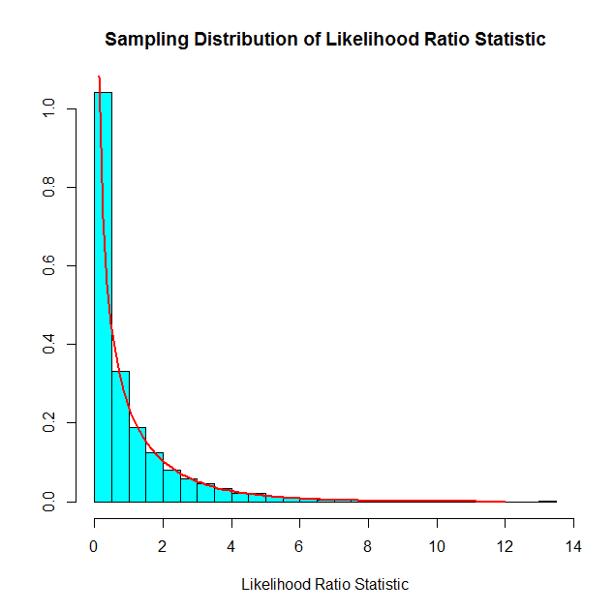

**For Exponential data the likelihood ratio statistic is a discrete or continuous random variable?**

**For Exponential data the likelihood ratio statistic is a continuous random variable.**

**How well does the Chi-squared(1) probability density function agree with the sampling distribution of the likelihood ratio statistic as approximate by the relative frequency histogram?**

**The Chi-squared(1) fits the relative frequency histogram very well. Although Chi-squared(1) is a normal distribution, and the sample size is not very big, all the columns are exactly on the line.**

**Problem 3: Fill in the information below based on your data which were generated using your ID number as the seed for the random number generator.**

**mu = 7**

**sigma =8**

**The first ten 95% confidence intervals for mu are:**

**[,1] [,2]**

**[1,] 6.489231 12.297250**

**[2,] 4.346364 11.734535**

**[3,] 1.501063 9.661879**

**[4,] 2.519505 10.269129**

**[5,] 7.210810 11.985302**

**[6,] 2.936993 9.927025**

**[7,] 2.154392 9.107261**

**[8,] 1.096694 6.261989**

**[9,] 3.734410 10.842946**

**[10,] 6.218023 12.454495**

**The proportion of 95% confidence intervals which contain the true value of mu = 0.949**

**How close is this proportion to 0.95? What are the reasons for this?**

**0.949 is very close to 0.95. For the 95% confidence intervals, we are 95% confident that the interval will contain the true value of theta, and 5% confident that the interval won’t contain the true value of theta.**

**The first ten 95% confidence intervals for sigma are:**

**[,1] [,2]**

**[1,] 5.493325 9.787108**

**[2,] 6.987859 12.449824**

**[3,] 7.718640 13.751810**

**[4,] 7.329728 13.058909**

**[5,] 4.515796 8.045507**

**[6,] 6.611293 11.778919**

**[7,] 6.576144 11.716296**

**[8,] 4.885426 8.704052**

**[9,] 6.723376 11.978611**

**[10,] 5.898563 10.509095**

**The proportion of 95% confidence intervals which contain the true value of sigma = 0.9518**

**How close is this proportion to 0.95? What are the reasons for this?**

**0.9518 is very close to 0.95. For the 95% confidence intervals, we are 95% confident that the interval will contain the true value of theta, and 5% confident that the interval won’t contain the true value of theta.**